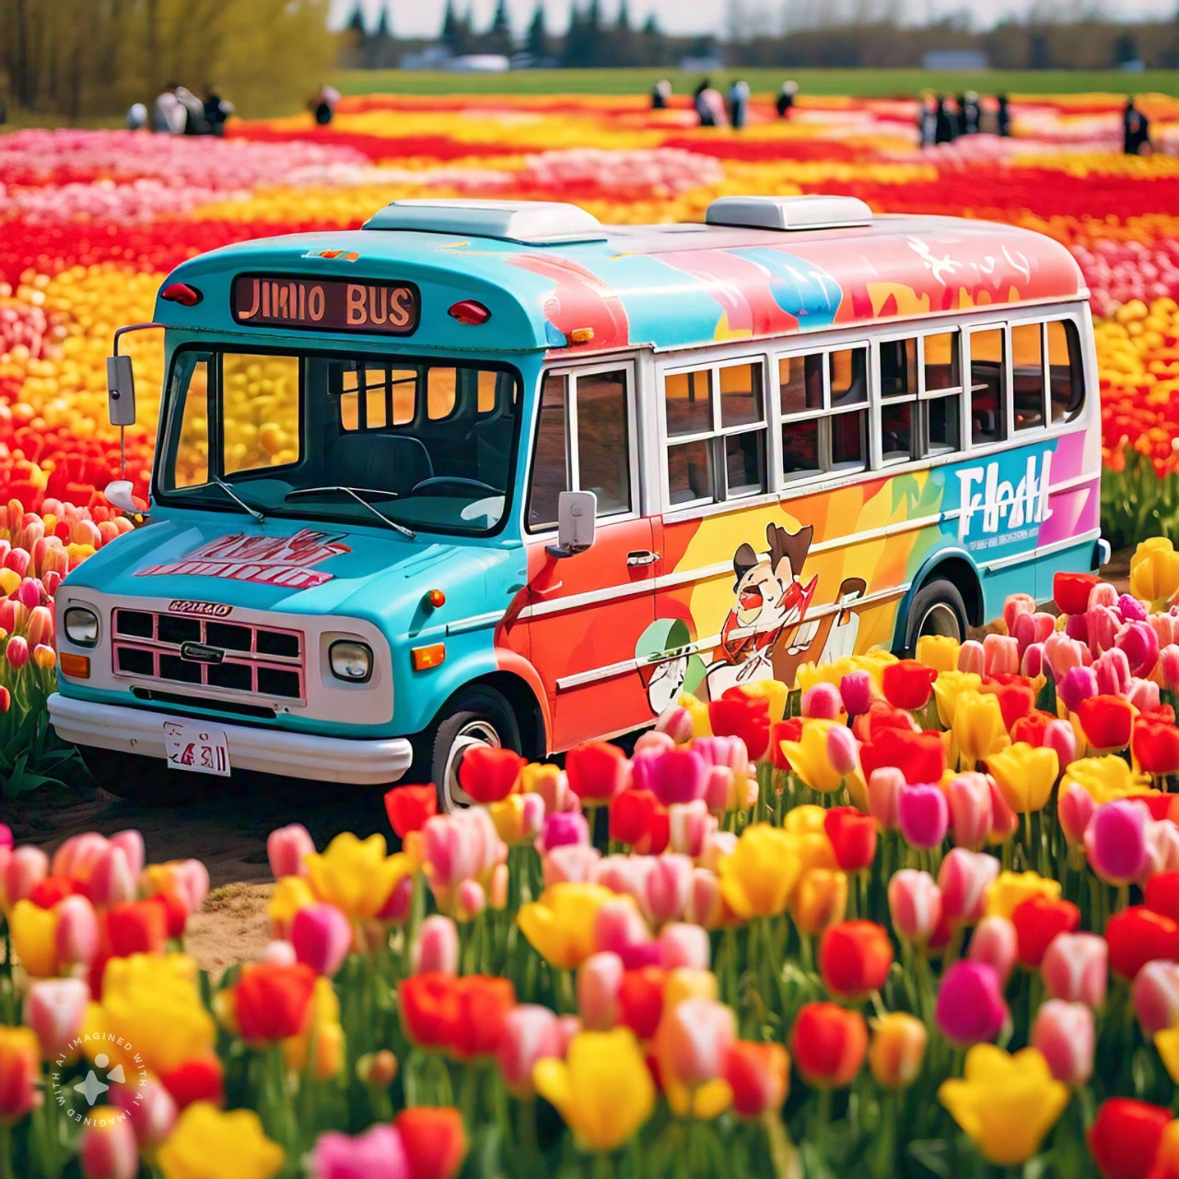

create a picture of jimin park the idol bus in a tulip field Here is your result!!



Create an image of a [person reading and outside there are autumn leaves falling and there is a cup of chocolate in the background

interprets an ai hallucinations about bts

Of course! Here is an interpretation of what an AI hallucination about BTS might look like, taking into account the common characteristics of this type of errors:

AI: "BTS announced yesterday that they will be moving to the Moon to record their next album. The members have been training in zero gravity so they can perform their choreographies on the lunar surface. In addition, it is rumored that the album will be entirely in ancient Korean and that they will include a song composed by aliens."